Title of Project
Adding value to Information Systems across CTUs

Abstract
At the November 2017 ISOG annual meeting delegates discussed the benefits of sharing of software, knowledge and skills between registered clinical trials units (CTUs) in order to help units avoid ‘re-inventing the wheel’ in respect of applications, reduce validation time and, potentially, join forces in the development of new applications.
The NIHR funded a one year project to produce a website to help CTUs assess information systems capabilities that will link in to the details about an individual trials unit’s capabilities on the UKCRC website.
The project was awarded as a joint collaboration between the Liverpool Clinical Trials Centre (then the Clinical Trials Research Centre) and Glasgow CTU.

Introduction
There are currently 47 fully registered and six provisionally registered clinical trials units (CTUs) within the UKCRC Registered CTU Network (https://cdn.ymaws.com/www.ukcrc-ctu.org.uk/resource/resmgr/registration_ids/2019-20_reg_ids_nov19.pdf). Each of these units has at least one, more often several Information Systems staff who develop, maintain and support the software required for each trials unit to operate and comply with Good Clinical Practice. All trials units will have a data collection system, randomisation system and a suite of tools to support their activities in data collection and trial management. Some of these tools are commercial off the shelf systems (COTS), some developed in-house, dependent upon the number of Information Systems staff within the trials unit.
Each of these applications must be supported and validated, potentially leading to a large amount of repetition and “re-invention of the wheel” across units, therefore resulting in a cost to the funding agencies that could be minimised if a more collaborative working model could be developed. However, different CTUs have different needs based upon the nature of their trials portfolio, as such not all software applications would be suitable for all CTUs. In addition, attempting to develop applications that are “one-size fits all” may, despite best intentions, lead to systems which are not fit for purpose.
The reliance on information systems to facilitate and increase the efficiency of clinical trials will only grow in the coming years. Coupled to the increased volume of data that is being routinely collected and the increasing regulatory requirements around data hosting and sharing, this means that having each CTU develop its own applications and infrastructure to solve some of the more common problems around linking and processing specific data sets, and implementing new security standards for web applications access, is inefficient. Furthermore, there is a recognised challenge [UKCRC ISOG] in the recruitment and retention of IS staff within trials units leading to low applications for vacancies thereby exacerbating units’ abilities to efficiently develop software solutions. A mechanism to facilitate collaborative working, and development of a library of applications that are available to other trials units therefore make sense, especially as many CTUs have common sources of trial grant funding.

Methods

In April 2019 over 30 staff members from the UKCRC registered CTUs came together and discussed ways to improve working in the area of IS for clinical trials and how best to facilitate collaboration between CTUs, including the development of a website with a searchable database of relevant information
The workshop covered 3 topic discussions. Attendees were split into 5 working groups, 6-7 attendees per table keeping members from the same CTU on different tables. The format for the day was that a presentation of the topic was made, then a 30 minute to an hour slot would be given for the working groups to discuss and write down their contributions and then each table would nominate a member to present their discussions.
(1) The first topic for discussion centred on what information people would like to know about other CTUs, what type of information should be collected, who should have access to the information, how the information should be maintained and how the site would be supported and managed.
Output from this discussion
Consensus from the group presentations showed that it would be useful to know:
- What system applications each CTU use e.g. for data collection, randomisation, IMP management, TMF storage, SOP management.
- Whether the systems are developed in-house, 3rd party bespoke, or off the shelf software.
- The platform, and development tools used.
- How the systems are validated e.g. paper scripts, automated testing tools, whether validation packages are available.
- Whether there are any training tools available.

Ensuring this information is pitched at the correct level and with enough detail would be key to its usefulness.
In addition to the above, having details of services and/or skills that can be shared e.g. training, validation services, hosting facilities, development expertise, IS for international trials, issues related to sponsorship, would also be valuable.
It was agreed that each CTU should manage their own information entered into the database.

(2) The second topic for discussion centred on collaborative projects, whether CTUs would be interested in collaborating with other CTUs, suggestions for types of collaborative projects and how this could be achieved.
Output from this discussion
Various suggestions were mooted for collaborative projects including:
- Electronic archiving/decommissioning
- Repository of best practices
- NHS Digital Toolkit
- CRF design/content templates
Use of automated validation tools

As well as project collaborations, attendees felt the website should include a forum for raising questions, sharing experiences, audit findings, news and information, useful tips, and training requests. These were all felt to be a useful way of collaborating.

(3) The third topic for discussion covered how collaborations could be achieved.
Output from this discussion
Discussions included how the collaborative projects would be managed, resourced, and prioritised, and how project tasks would be split and the quality of work assured.
Key to the success of the collaborative projects would be: having agreement from relevant CTU leadership teams; a quality plan with clear roles, responsibilities, accountabilities, and timescales; clear lines of communication; team spirit; an allowance for contingencies.

Overall it was agreed that the sharing of CTUs’ applications, services, skills, collaborative projects and the forum should only be available to CTUs registered with the UKCRC network.

Website
Based on the output from the workshop a website www.trialaborate.org.uk has been created. The site will be hosted and managed overall by Liverpool Clinical Trials Centre.

In order to gain access and interact with the website each CTU have been asked to nominate an admin user(s). As the CTU admin user, they will have the responsibility for maintaining oversight of the users from their CTU and the information (bio) about their CTU and applications, services and skills.
A form was sent to each CTU Director in March requesting details of the nominated admin user(s) and overview information about the CTU. The forms will be returned to the Liverpool Clinical Trials Centre who will be responsible for adding the CTU, CTU details and administrators to the website.
An email is sent to the individual CTU administrator(s) once the CTU’s details have been added and the administrator(s) account is live.
The website is made up of the following pages:

‘Home’ page which will be visible to unregistered users and will contain general information about the site, a link to the UKCRC CTU Network website, a link to the Statisticians Search for Oversight website (SOS), and a ‘Contact Us’ facility for unregistered users to request further information. For registered users, who have logged into the site, the home page will also show any collaborative projects that are currently ongoing/requesting collaborators.

‘About’ page which will be visible to unregistered users and will give an overview of what the website offers for registered users, a link to the UKCRC website, and a ‘Contact Us’ facility for unregistered users to request further information.

‘Login’ Page - Only people working for a UKCRC Registered CTU can register for access to the other sections/pages within the website. When a user requests access an email is sent to the administrator(s) for that CTU and they will need to approve the user request for the user to gain access.

Once logged into the site the following pages will be made available according to the user’s access level:

- Account Page
All users will be able to amend their password within this section.
Administrators will have the additional facilities to manage their own CTU users, CTU details - address, logo, address, CTU sections (e.g. QA, IS, STATS etc.) and the description of applications/services/skills pertaining to their CTU.
Defining the applications/services/skills includes an overview of the service type, whether it can be shared and if so how it can be shared (e.g. purchased).
In addition, for application types, a brief description of the application, details of the application development, platform etc., can also be entered with the ability to add screenshots.

- Census page
This page will indicate which CTUs have registered with the Trialaborate site. All users will be able to browse the details of the CTUs registered on the system, including the CTU bio information, applications, services etc.

Applications/Service page
Accessible from the Application/Services link within the Census page, users can view the applications/services/skills by system/service type across all CTUs or individual CTUs. Filters are available allowing users to drill for specific text.

A ‘Request further information’ box allows users to state what further information they require through an email sent to the administrator(s) for the CTU suppling the application/service.

- Collab Projects page
Only administrators for a CTU will be able to add new projects.
Adding a project includes:
- Giving the Project a name
- Providing a full and short description of the project. The short description will be used when the projects are displayed in the list of Collab projects posted.
- Ability to attach documents
- Partner Requirements - what specific skills are required for the collaboration
- Proposed project start date

For all other registered users the page will show all Collaboration projects posted, the project name, short description and the status of the project showing whether the project is ‘looking for collaborators’, ‘collaborating’, completed or cancelled.
By selecting on a project, full details of the project description and partner requirements are displayed including a ‘Register interest’ box.

The ‘Register Interest’ box allows users to fill in what interest they have in the selected project, and an email is sent to the administrator(s) for the Originator of the Collab project.

- Forum Page
The Forum page is split into 2 areas, ‘Support’ and ‘Learn + Share’, each area having dedicated channels for particular topics. The channels and areas are configurable by the site administrator. At the point of going live the site will contain 5 channels in the Support area - eTMF, Inspections, MACRO, News and Information, and Redcap. The Learn + Share area will have 3 channels – Resources, Share your Work and Tutorials.

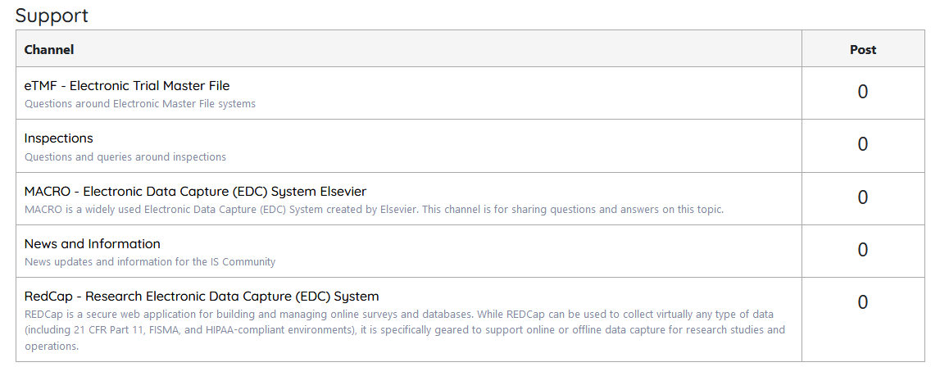

All users can add new posts, reply to posts, edit or delete their own posts or if they feel comments are inappropriate report the post to the site administrator

As part of the user account management each user can select whether they wish to receive email notifications when someone responds to one of their forum posts.

The site will also include a search facility; initially the search will only look through the Forum discussions but could be expanded at a later date to search the whole site.

Results and Conclusion
The workshop was well received.
During the workshop discussions, Manchester CTU said they were running REDCAP training sessions and offered to open them to other CTUs. Such an offer of sharing of their knowledge and skills to others prior to the launch of the website bodes well.
The responses from the workshop were positive and attendees were keen for the site to be made available.
The only real concern noted was around how the collaborative projects would/could be funded and managed. This will need to be reviewed 6 months post release of the website.

Dissemination
The website www.trialaborate.org.uk was made live on the 3rd April 2020.
A video demonstrating the use of the site will be made available at the end of April 2020.
At the end of September, a newsletter will be sent to each CTU with a review of the use of the system.
A demonstration of the system will be given at the next ISOG meeting with a review of how the system had been received, and what improvements if any could be made.

Acknowledgements
The project was funded by the NIHR through the CTU support funding scheme.
The project team comprised:
Linda Kane (Information Systems Quality Assurance Tester, University of Liverpool Clinical Trials Centre) – joint Project Lead and presenter at the workshop
Sharon Kean (Director of Information Systems, Glasgow Clinical Trials Unit and Chair of UKCRC Information Systems Operational Group subcommittee) – joint Project Lead and presenter at the workshop
Anthony Shorrock (Digital Solutions Architect, University of Liverpool Clinical Trials Centre) – Site development and video
Dr Duncan Appelbe (Senior Research Information Specialist, Oxford Trauma Group, Nuffield Department of Orthopaedics, Rheumatology and Musculoskeletal Sciences (NDORMS), University of Oxford) – involved with the original concept of the project and joint presenter at the workshop
Professor Paula Williamson (Director, Clinical Trials Research Centre) – CTU Director at time of application, involved with the original concept of the project and input to website design
Professor Carrol Gamble (Director, Liverpool Clinical Trials Centre) – CTU Director at time of project completion, involved with input to website design
We also acknowledge the support of the UKCRC Registered CTU Network for help in the workshop organisation and sending out the correspondence to the UKCRC CTUs.

Conflicts of Interest Declaration
The authors had no conflicts of interest with relevance to this project.

